Naslov : moberl 3000_amws – created from moberl 3000_amws  : AVTOMATSKI MERILNI SISTEM ZA SPREMLJANJE STANJA OKOLJA  konfiguracija : moberl_3000  št. projekta : moberl_3000  faza projekta : pzi-3000.5  faze testa : t-3000.5.5  datum/revizija : 10.01.2012 / 2013-1-7  pripravil/testiral : B. Černač, A.Kolenc  Name: <šifra lokacije>_Mxxxx_<lokacija>  Type: 3000_1000EO800  SN: < serial number>  UC8410-LX Nport 5650 Camera  eth0: <IP> eth0: <IP> CAM1: <IP>  eth1: 192.168.4.127 CAM2: <IP>  eth2: 192.168.5.127 CAM3: <IP> | ref smp11d_ref.doc  bs 3000_bs_1000EO800.pdf,  3000_bs_1000EO800_io.pdf  tp 3000_tp-N2-N3.pdf  mo 3000_5_8_amws_1000EO800.pdf  3000_5_4_amws_1000EO800.pdf  3000_mo_1000EO800.pdf  3000_mo_1000EO800_bw.pdf  3000_mo_1000EO800_co.pdf  links: http://slmweb.rzs-hm.si/SSSV_meteo/Meteo_senzorika/  http://mobervis.arso.sigov.si/

./uc8410/ | uc8410-LX (24Vdc) | 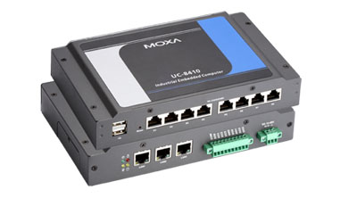 | N2-x  8x ttyMx |  | uc8410d_ref.doc
./Nport5650/ | Nport5650-DT-J (24Vdc) | 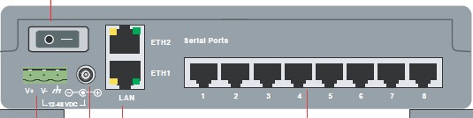 | N3-x  8x portx

|--< | Sensor/Interface | jpg | dev-port/ch  ch.. ttyMx or ip:portx | Default interface & uart config  Current interface & uart config | Documentation | STATUS
|--< | Smart Pyranometer  - global_solar_radiation  - diffusse_solar_radiation  smp11  elec. (5-30Vdc/60mW)  cvf-3 (ventilation unit)  ventilation (12Vdx/10W) | 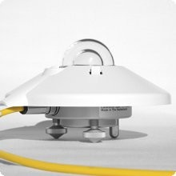  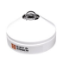 |  | Def: rs485_2w/19200/8/even/1  Curr: rs485_2w/  PROTOKOL: RTU MODBUS | Sensor Management  smp11d.sh  Start sensor deamon  ./smp11d smp1d.xml  Xls exel Process Sensor Model  Xml Process Sensor Config  smp11d.xml  smp11d.h.xml  [optional]  Data Processing & output format  sensord_processing.pdf  sensord_format.pdf  User Guides:  smp11_UserGuid.pdf  Technical Specifications  smp11_datasheet.pdf
Wiring sheme:
smp11_bs.pdf
smp11_mo_B3-5.pdf
smp11_mo_B3-5_II.pdf
 |  |  |  |  | Order form:
LEGENDA:
ref referenčni dokumnet
bs blok sheme
tp topologija
mo sheme montaže ožičenja

